Texas Commission on Environmental Quality
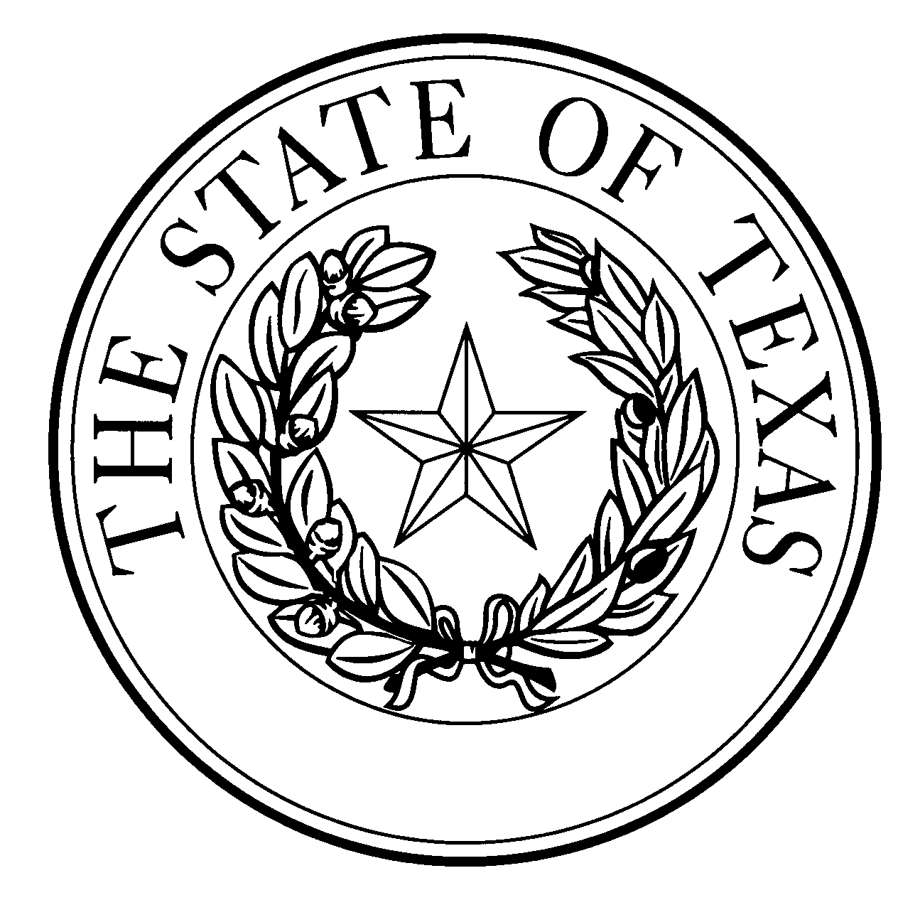
  - Notice of Concentrated Animal Feeding Operation Application
General Permit Authorization No. TXG920985
Application. Full Circle Jerseys, P.O. Box 1505, Dalhart, Texas, 79022 has applied to the Texas Commission on Environmental Quality (TCEQ) under General Permit No. TXG920000 for a non-substantial change to the terms of the nutrient management plan (NMP) previously submitted to the TCEQ. The Applicant is proposing to add a manure digester and manure/sand separation to the facility. The retention control structure (RCS) design calculations for RCS #1 (covered digester), #2 (storage pond) and #3 (storage pond) were revised; and there are no proposed changes to RCS #4. The facility maps were updated to reflect these changes. The authorized maximum capacity of 12,000 total dairy cattle, of which 5,200 are milking, the total land application area of 1,382 acres, and the list of alternative crops and yield goals remain unchanged. The notice of change application and the updated NMP were received by TCEQ on December 21, 2021.
No discharge of pollutants into the waters in the state is authorized by this general permit except under chronic or catastrophic rainfall conditions or events. All waste and wastewater will be beneficially used on agricultural land.
The facility is located at 3000 Beach Lane, Dalhart, Dallam County, Texas. The facility is located in the drainage area of Rita Blanca Lake in Segment No. 0105 of the Canadian River Basin. The following link to an electronic map of the site or facility’s general location is provided as a public courtesy and is not part of the application or notice. https://tceq.maps.arcgis.com/apps/webappviewer/index.html?id=db5bac44afbc468bbddd360f8168250f&marker=-102.53099%2C36.13436&level=12. For the exact location, refer to the application.
The Executive Director of the TCEQ has approved the proposed non-substantial change to the terms of the NMP. The revised terms of the NMP have been included in the permit record and it is available at the TCEQ’s Central Records, 12100 Park 35 Circle Austin, Texas 78753.
Information. For additional information about this application, contact Kayla Robichaux at (512) 239-4742. Si desea información en Español, puede llamar al 1-800-687-4040. General information regarding the TCEQ can be found at our web site at www.tceq.texas.gov/.

Issued: May 16, 2022

